**CSE102L Computer Programming Lab**

**LAB # 2**



**2020**

**Submitted to:**

**Engr. Abdullah Hamid**

**Submitted by:**

**TAYYABA**

**Registration No :**

**19PWCSE1854**

**Semester: 2nd**

**Class Section:** **C**

“On my honor, as student of University of Engineering and Technology,

I have neither given nor received unauthorized assistance on this

academic work.”

March 16 , 2020

**Department of Computer Systems Engineering**

**University Of Engineering And Technology**

## Objectives:

**To be familiar with Relational & Logical Operators**

**To understand the programming knowledge using Decision Statements (if, if-else, if-else ladder, Nested if-else)**

## Task # 1

**Title:** Display the largest among three numbers using if else statement?

**Code:**

**#include<iostream>**

**using namespace std;**

**main()**

**{**

**int x,y,z;**

**cout<<"Enter 1st Num = \n\n";**

**cin>>x;**

**cout<<"Enter 2nd Num = \n\n";**

**cin>>y;**

**cout<<"Enter 3rd Num = \n\n";**

**cin >> z;**

**if (x>y && x>z)**

**{**

**cout<<x<<" is greater";**

**}**

**else if (y>x && y>z)**

**{**

**cout<<y<< " is greater";**

**}**

**else**

**{**

**cout<<z<< " is greater";**

**}**

**}**

**Output (Compilation, Debugging & Testing):**

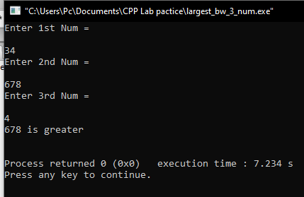

## Task # 2

**Title:** Check whether a number is even or odd?

**Code:**

**#include<iostream>**

**using namespace std;**

**main()**

**{**

**int n;**

**cout<<"Enter a number";**

**cin>>n;**

**if (n>0)**

**{**

**if(n%2==0)**

**{**

**cout<<"Number is even and greater then zero \n\n";**

**}**

**else**

**{**

**cout<<"Number is odd and greater then zero \n\n";**

**}**

**}**

**else if (n<0)**

**{**

**if (n%2==0)**

**{**

**cout<<"Number is even and smaller then zero \n\n";**

**}**

**else**

**{**

**cout<<"Number is odd and smaller then zero \n\n";**

**}**

**}**

**else**

**{**

**cout<<"Number is zero \n\n";**

**}**

**}**

**Output (Compilation, Debugging & Testing):**

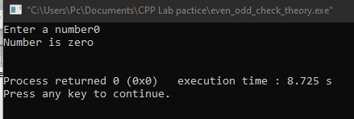

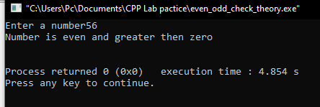

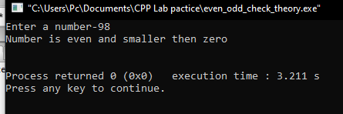

## Task # 3

**Title** Check the greater of two numbers using ternary operator?

**Code:**

**#include<iostream>**

**using namespace std;**

**main()**

**{**

**int x,y;**

**cout<<"Enter 1st Number = ";**

**cin>>x;**

**cout<<"Enter 2nd Number = ";**

**cin>>y;**

**x>y ? cout<<x<< " is greater" : cout<<y <<"is greater";**

**return 0;**

**}**

**Output (Compilation, Debugging & Testing):**

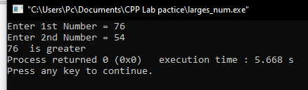

## Task # 4

**Title** Write a MarksSheet program, input 5 subject marks from user and show data on screen, with percentage, grade and average marks (Assume total marks = 100).

**Code:**

**#include<iostream>**

**using namespace std;**

**//bool has by default 0 or false value**

**main()**

**{**

**int maths,eng,cpp,cs1,isl;**

**cout<<"Enter the Maths marks = ";**

**cin>>maths;**

**cout<<"Enter the English marks = ";**

**cin>>eng;**

**cout<<"Enter the CPP marks = ";**

**cin>>cpp;**

**cout<<"Enter the CS1 marks = ";**

**cin>>cs1;**

**cout<<"Enter the Islamiyat marks = ";**

**cin>>isl;**

**cout<<"\n\nEnglish marks = "<<eng<<endl;**

**cout<<"Maths marks = "<<maths<<endl;**

**cout<<"CPP marks = "<<cpp<<endl;**

**cout<<"CS1 marks = "<<cs1<<endl;**

**cout<<"Islamiyat marks = "<<isl<<endl;**

**float tmarks;**

**tmarks=(eng+maths+cpp+cs1+isl);**

**cout<<"\n\nTotal marks = "<<tmarks;**

**if (tmarks>=90)**

**{**

**cout<<"\n\n A grade \n\n";**

**}**

**else if (tmarks>=80)**

**{**

**cout<<"B grade \n\n";**

**}**

**else if(tmarks>=70)**

**{**

**cout<<"C grade \n\n";**

**}**

**else{**

**cout<<" Fail \n\n";**

**}**

**cout<<"Average marks = "<<(tmarks / 500)*100<<"\n\n";**

**}**

**Output (Compilation, Debugging & Testing):**

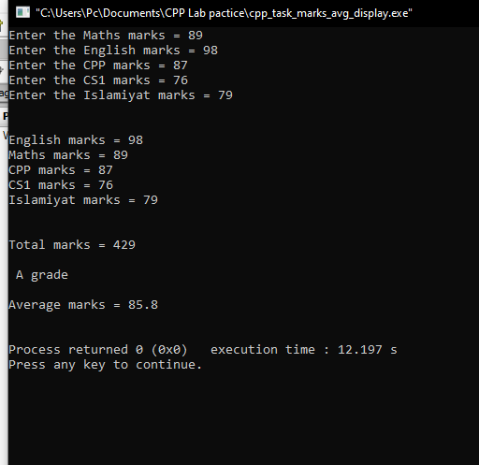

## Task # 5

**Title** Write a C++ program that takes two operands and one operator from the user, the program should implement basic arithmetic operations – sum, average, product, difference, quotient, remainder, and, or and not of given numbers etc.

**Code:**

**#include<iostream>**

**#include<cmath>**

**using namespace std;**

**main()**

**{**

**int x,y;**

**string z;**

**cout<<"Enter 1st Number = ";**

**cin>>x;**

**cout<<"\nEnter operand = ";**

**cin>>z;**

**cout<<"\n Enter 2nd Number = ";**

**cin>>y;**

**if (z == "+")**

**{**

**cout<<x<<" + "<<y<<" = "<< x+y;**

**}**

**else if(z == "-")**

**{**

**cout<<x<<" - "<<y<< " = "<< x-y;**

**}**

**else if(z == "*")**

**{**

**cout<<x<<" * "<<y<< " = "<< x*y;**

**}**

**else if(z == "/")**

**{**

**cout<<x<<" / "<<y<< " = "<< x/y;**

**}**

**else if(z == "%")**

**{**

**cout<<x<<" % "<<y<< " = "<< x%y;**

**}**

**else if(z == "avg")**

**{**

**cout<<x<<" average "<<y<< " = "<< (x+y)/2;**

**}**

**else if(z == "&")**

**{**

**cout<<x<< "&&" <<y<< " = "<< x&&y;**

**}**

**else if(z == "|")**

**{**

**cout<<x<< "||" <<y<< " = "<< x||y;**

**}**

**else if(z == "~")**

**{**

**cout<< ~y<< " = "<< ~y;**

**}**

**else**

**{**

**cout<<"Wrong selection...";**

**}**

**}**

**Output (Compilation, Debugging & Testing):**

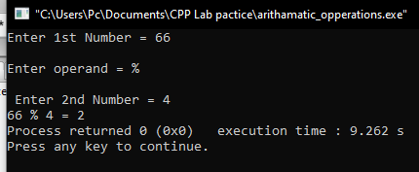

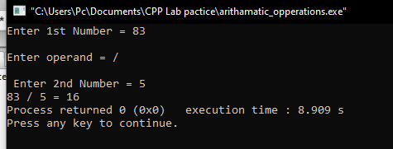

## Task # 6

**Title** Write a program that asks a number and test the number whether it is multiple of 5 or not, divisible by 7 but not by eleven. (all three conditions should match)

**Code:**

**#include<iostream>**

**#include<cmath>**

**using namespace std;**

**main()**

**{**

**int x;**

**cout << "ENTER a number = ";**

**cin>>x;**

**if( x%5 == 0)**

**{**

**cout<<"\n\nMultiple of 5.\n\n";**

**}**

**else{**

**cout<<"Not a Multiple of 5.\n\n";**

**}**

**if(x%7 == 0)**

**{**

**cout<<"Divisible of 7.\n\n";**

**}**

**else**

**{**

**cout<<"Not a Divisible of 7.\n\n";**

**}**

**if(x%11 == 0)**

**{**

**cout<<"Divisible of 11.\n\n";**

**}**

**else{**

**cout<<"Not a Divisible of 11.\n\n";**

**}**

**return 0;**

**}**

**Output (Compilation, Debugging & Testing):**

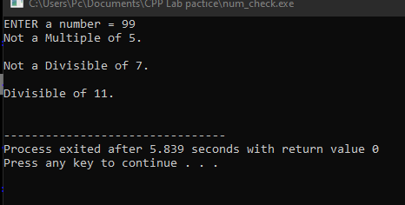

## Task # 7

**Title** Check whether the entered character is vowel or consonant?

**Code:**

**#include<iostream>**

**#include<cmath>**

**using namespace std;**

**main()**

**{**

**char x;**

**cout << "ENTER a Character = ";**

**cin>>x;**

**if(x == 'a')**

**{**

**cout<<"Entered character is a vowel.";**

**}**

**else if(x == 'e')**

**{**

**cout<<"Entered character is a vowel.";**

**}**

**else if(x == 'i')**

**{**

**cout<<"Entered character is a vowel.";**

**}**

**else if(x == 'o')**

**{**

**cout<<"Entered character is a vowel.";**

**}**

**else if(x == 'u')**

**{**

**cout<<"Entered character is a vowel.";**

**}**

**else**

**{**

**cout<<"Entered character is a consonant.";**

**}**

**}**

**Output (Compilation, Debugging & Testing):**

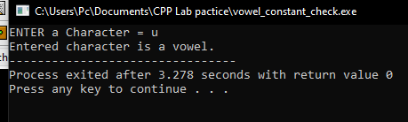

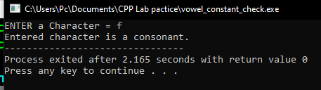

## Task # 8

**Title** Write a program that takes the week day number as input from user and print the day name of week. E.g., Print Monday if week day number is equal to 1. Similarly, check condition for all 7 days and print the corresponding day name. Print an error message if an invalid number is entered.

**Code:**

**#include<iostream>**

**#include<cmath>**

**using namespace std;**

**main()**

**{**

**int x;**

**cout << "ENTER the number of week's day = ";**

**cin>>x;**

**if(x == 1)**

**{**

**cout<<"IT's Monday.";**

**}**

**else if(x == 2)**

**{**

**cout<<"IT's Tuesday.";**

**}**

**else if(x == 3)**

**{**

**cout<<"IT's Wednesday.";**

**}**

**else if(x == 4)**

**{**

**cout<<"IT's Thursday.";**

**}**

**else if(x == 5)**

**{**

**cout<<"IT's Friday.";**

**}**

**else if(x == 6)**

**{**

**cout<<"IT's Saturday.";**

**}**

**else if(x == 7)**

**{**

**cout<<"IT's Sunday.";**

**}**

**else**

**{**

**cout<<" A week has only 7 days. \n You entered wrong number.\n\n\n";**

**}**

**}**

**Output (Compilation, Debugging & Testing):**



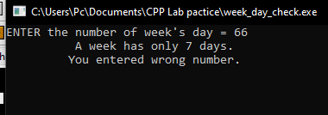

## Task # 9

**Title** Write a C++ program to enter month number between (1-12) and print number of days in month

**Code:**

**#include<iostream>**

**#include<cmath>**

**using namespace std;**

**main()**

**{**

**int x;**

**cout << "ENTER the number of Month = ";**

**cin>>x;**

**if(x == 1)**

**{**

**cout<<"IT's January.";**

**cout<<"IT has 31 days.";**

**}**

**else if(x == 2)**

**{**

**cout<<"IT's Februry.";**

**cout<<"\nIT has 28 days.\n But if it's a leap year it has 29 days\n\n\n";**

**}**

**else if(x == 3)**

**{**

**cout<<"IT's March.";**

**cout<<"\nIT has 31 days.";**

**}**

**else if(x == 4)**

**{**

**cout<<"IT's April.";**

**cout<<"\nIT has 30 days.";**

**}**

**else if(x == 5)**

**{**

**cout<<"IT's May.";**

**cout<<"\nIT has 31 days.";**

**}**

**else if(x == 6)**

**{**

**cout<<"IT's Jun.";**

**cout<<"\nIT has 30 days.";**

**}**

**else if(x == 7)**

**{**

**cout<<"IT's July.";**

**cout<<"\nIT has 31 days.";**

**}**

**else if(x == 8)**

**{**

**cout<<"IT's August.";**

**cout<<"\nIT has 31 days.";**

**}**

**else if(x == 9)**

**{**

**cout<<"IT's September.";**

**cout<<"\nIT has 30 days.";**

**}**

**else if(x == 10)**

**{**

**cout<<"IT's October.";**

**cout<<"\nIT has 31 days.";**

**}**

**else if(x == 11)**

**{**

**cout<<"IT's November.";**

**cout<<"\nIT has 30 days.";**

**}**

**else if(x == 12)**

**{**

**cout<<"IT's December.";**

**cout<<"\nIT has 31 days.";**

**}**

**else**

**{**

**cout<<"\n\n A year has only 12 months. You Entered wrong number.";**

**}**

**}**

**Output (Compilation, Debugging & Testing):**

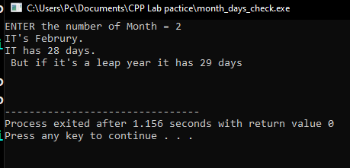

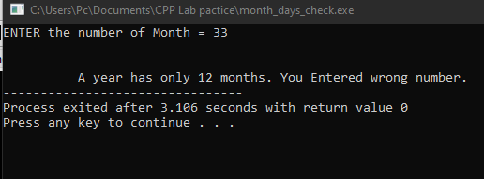

## Task # 10

**Title** Write a program to calculate and print the Electricity bill of a given customer. The customer id and unit consumed by the user should be taken from the keyboard and display the total amount to pay to the customer. The charges are as follow :

|  |  |
| --- | --- |
| **Unit** | **Charge/unit** |
| upto 199 | @1.20 |
| 200 and above but less than 400 | @1.50 |
| 400 and above but less than 600 | @1.80 |
| 600 and above | @2.00 |

If bill exceeds Rs. 400 then a surcharge of 15% will be charged and the minimum bill should be of Rs. 100/-

**Test Data:**

1001

800

**Expected Output:**

Customer IDNO: 1001

Units Consumed: 800

Amount Charges @Rs. 2.00 per unit: 1600.00

Surchage Amount : 240.00

Net Amount Paid By the Customer : 1840.00

**Code:**

**#include<iostream>**

**using namespace std;**

**int main()**

**{**

**float ID,Unit,ans,ans2,ans3;**

**cout<<"Enter the Customer I.D"<<endl;**

**cin>>ID;**

**cout<<"Enter the Units Consumed"<<endl;**

**cin>>Unit;**

**if (Unit <= 199)**

**{**

**ans=(1.20*Unit);**

**if (ans>400)**

**{**

**ans2=(ans*0.15);**

**ans3=(ans2+ans);**

**cout<<"Customer I.D:"<<ID<<endl;**

**cout<<"Units Consumed:"<<Unit<<endl;**

**cout<<"Amount Charges @ Rs.1.20 per unit:"<<ans<<endl;**

**cout<<"Surcharge Amount:"<<ans2<<endl;**

**cout<<"Net Amount Paid by Customer:"<<ans3;**

**}**

**else**

**cout<<"Customer I.D:"<<ID<<endl;**

**cout<<"Units Consumed:"<<Unit<<endl;**

**cout<<"Amount Charges @ Rs.1.20 per unit:"<<ans<<endl;**

**cout<<"Net Amount Paid by Customer:"<<ans;**

**}**

**if (Unit <= 400)**

**{**

**ans=(1.50*Unit);**

**if (ans>400)**

**{**

**ans2=(ans*0.15);**

**ans3=(ans2+ans);**

**cout<<"Customer I.D:"<<ID<<endl;**

**cout<<"Units Consumed:"<<Unit<<endl;**

**cout<<"Amount Charges @ Rs.1.50 per unit:"<<ans<<endl;**

**cout<<"Surcharge Amount:"<<ans2<<endl;**

**cout<<"Net Amount Paid by Customer:"<<ans3<<endl;**

**}**

**else**

**cout<<"Customer I.D:"<<ID<<endl;**

**cout<<"Units Consumed:"<<Unit<<endl;**

**cout<<"Amount Charges @ Rs.1.50 per unit:"<<ans<<endl;**

**}**

**if (Unit <= 600)**

**{**

**ans=(1.80*Unit);**

**if (ans>400)**

**{**

**ans2=(ans*0.15);**

**ans3=(ans2+ans);**

**cout<<"Customer I.D:"<<ID<<endl;**

**cout<<"Units Consumed:"<<Unit<<endl;**

**cout<<"Amount Charges @ Rs.1.80 per unit:"<<ans<<endl;**

**cout<<"Surcharge Amount:"<<ans2<<endl;**

**cout<<"Net Amount Paid by Customer:"<<ans3<<endl;**

**}**

**else**

**cout<<"Customer I.D:"<<ID<<endl;**

**cout<<"Units Consumed:"<<Unit<<endl;**

**cout<<"Amount Charges @ Rs.1.80 per unit:"<<ans<<endl;**

**}**

**if (Unit > 600)**

**{**

**ans=(2.00*Unit);**

**if (ans>400)**

**{**

**ans2=(ans*0.15);**

**ans3=(ans2+ans);**

**cout<<"Customer I.D:"<<ID<<endl;**

**cout<<"Units Consumed:"<<Unit<<endl;**

**cout<<"Amount Charges @ Rs.2.00 per unit:"<<ans<<endl;**

**cout<<"Surcharge Amount:"<<ans2<<endl;**

**cout<<"Net Amount Paid by Customer:"<<ans3<<endl;**

**}**

**}**

**return 0;**

**}**

**Output (Compilation, Debugging & Testing):**

